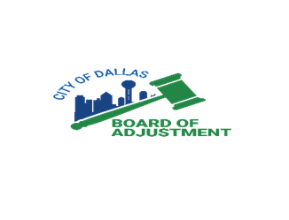
Board of Adjustment
FY 2025-2026 Schedule
Intake/Filing Deadline | Hearing Date - Panel
November 28, 2025  Prescreen Goal: November 14, 2025 | January 20, 21, & 22, 2026  Panel Order: A, B, & C
December 26, 2025  Prescreen Goal: December 12, 2025 | February 17, 18, & 19, 2026  Panel Order: A, B, & C
January 23, 2026  Prescreen Goal: January 9, 2026 | March 16, 17, & 18, 2026  Panel Order: C, A, & B
February 20, 2026  Prescreen Goal: February 6, 2026 | April 13, 14, & 15, 2026  Panel Order: C, A, & B
March 27, 2026  Prescreen Goal: March 13, 2026 | May 18, 19, & 20, 2026  Panel Order: C, A, & B
April 24, 2026  Prescreen Goal: April 10, 2026 | June 15, 16, & 17, 2026  Panel Order: C, A, & B
May 22, 2026  Prescreen Goal: May 8, 2026 | July 13, 14, & 15, 2026  Panel Order: C, A, & B
June 26, 2026  Prescreen Goal: June 12, 2026 | August 17, 18, & 19, 2026  Panel Order: C, A, & B
July 24, 2026  Prescreen Goal: July 10, 2026 | September 14, 15, & 16, 2026  Panel Order: C, A, & B
August 28, 2026  Prescreen Goal: August 14, 2026 | October 19, 20, & 21, 2026  Panel Order: C, A, & B
September 25, 2026  Prescreen Goal: September 11, 2026 | November 16, 17, & 18, 2026  Panel Order: C, A, & B
October 23, 2026  Prescreen Goal: October 9, 2026 | December 14, 15, & 16, 2026  Panel Order: C, A, & B
Full Board Meeting | October 27, 2026
Intake/filing closes at 12:00 pm on the day of the deadline.

