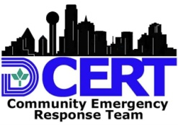
DALLAS-CERT FORMS
INCIDENT MANAGEMENT CHECK LIST
CERT Team: | Notes | Activity Log # | Complete IC Int’l
Cover Sheet Incident Name Date Operational Period
Dallas CERT 001 CERT Damage Assessment
Dallas CERT 203-2a & b CERT Personnel Resources |  | 003
Dallas CERT 203-1 CERT Team Assignment List |  | 001
Dallas CERT 214-1 & 2 CERT Activity Log |  | 002
Dallas CERT 002 CERT Task Sheet Status
Dallas CERT 003 CERT Operational Task Sheet
Dallas CERT 004 CERT Message Form
Dallas CERT 005 CERT Equipment Resources
Dallas CERT 201-1 & 2 CERT Incident Briefing
Dallas CERT 006-1 & 2 CERT Medical Treatment Record
Dallas CERT 007 CERT Medical Triage Record

