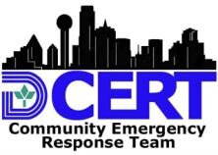
Dallas CERT OPERATIONAL TASK SHEET

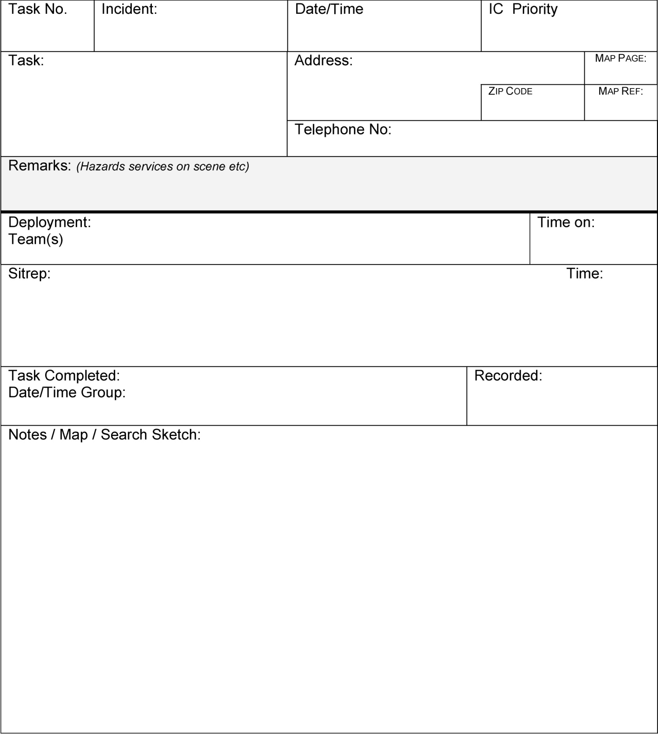
Dallas CERT 003 Operational Task Sheet
Instructions: Logger to filled out per Incident Commander task allocation / priority.
Handed to Operations Chief for allocation to teams

