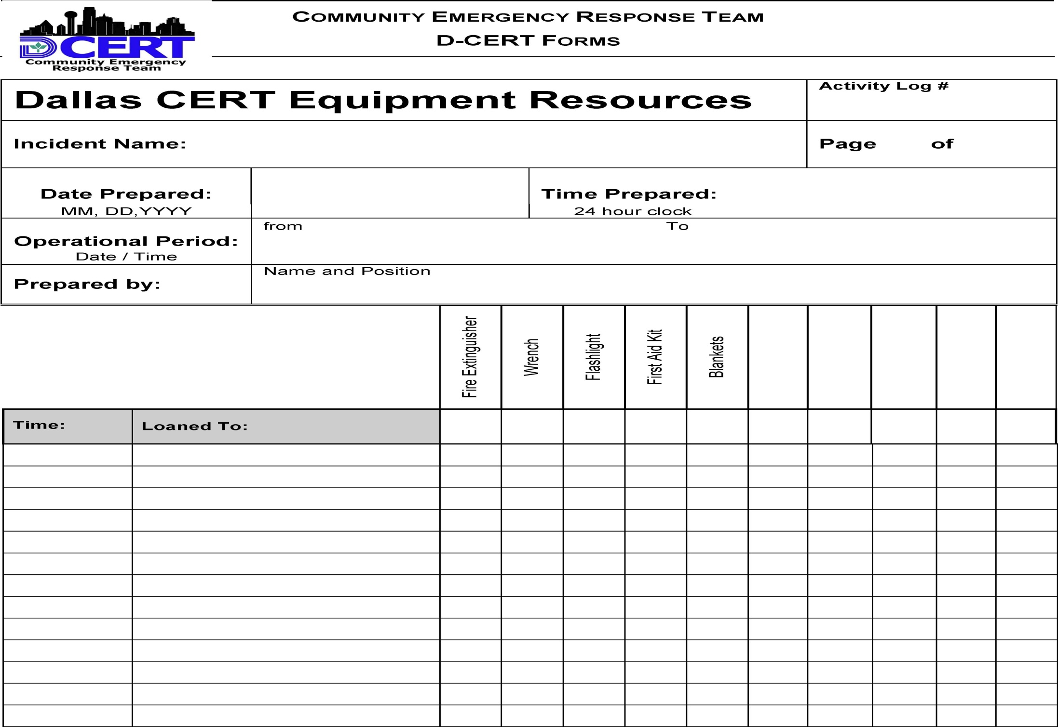
FOR USE BY LOGISTICS AND STAGING
Enter equipment and supplies as they come in and out. Total periodically. If an item is returned empty (for instance, a fire extinguisher), add it back in and circle the number, so you don’t include it in your next total.
Dallas CERT 005 Equipment Resources

